For activating virtual environment:
Cd C:\venv\Scripts
Type activate
virtual environment will get activate now
(venv) C:\venv\Scripts
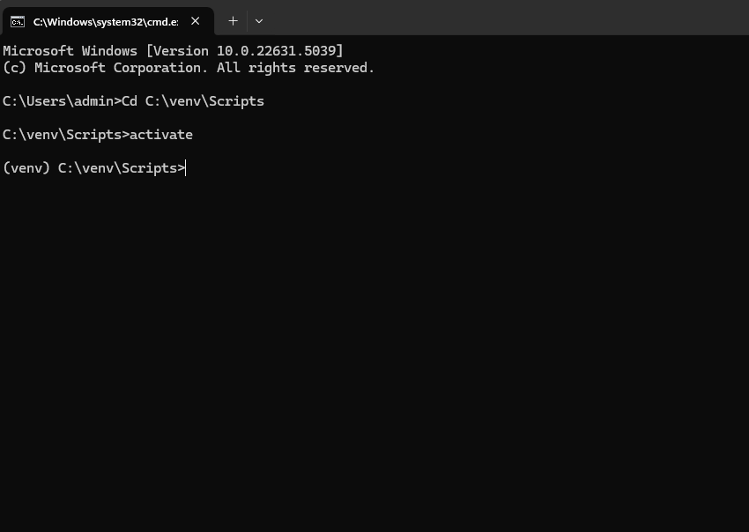

For running surveygenius:
Cd C:\venv\qualityreview_new_api\quality
Run command python manage.py runserver 192.168.1.198:8000
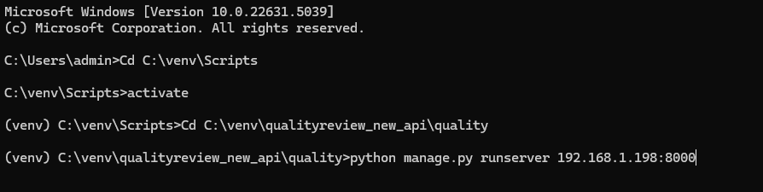
Running task.py file:
Check visual studio code is on or not
If Not:
Open new cmd tab
Go to Cd C:\venv\Scripts
Type activate
Then go to cd C:\venv\qualityreview_new_api\quality
Type tasks.py

